Bootstrap Course

I have learned to use bootstrap-tool more diverse and learned its efficiency. I used it with my custom style to make site responsiveness.

Before this course I didn’t use breadcrumbs and badges and now I used those as link. Problems with this course were with z-index and responsiveness. Those are the main problems always. Main problem was add some content to my portfolio, because I don’t have any experience in IT-jobs. Also this courses Project was little bit too wide and I spend a lot of time with it. I’m also in HTML-CSS-JavaScript -course and it has also portfolio-website project so I made little bit different site for it.

Index Page

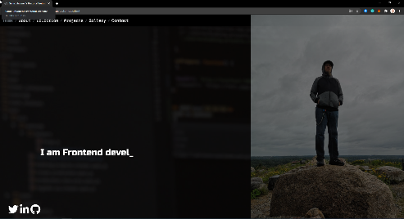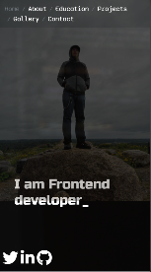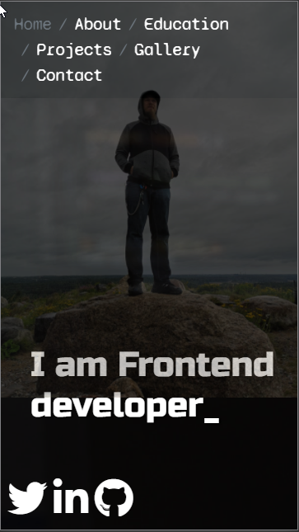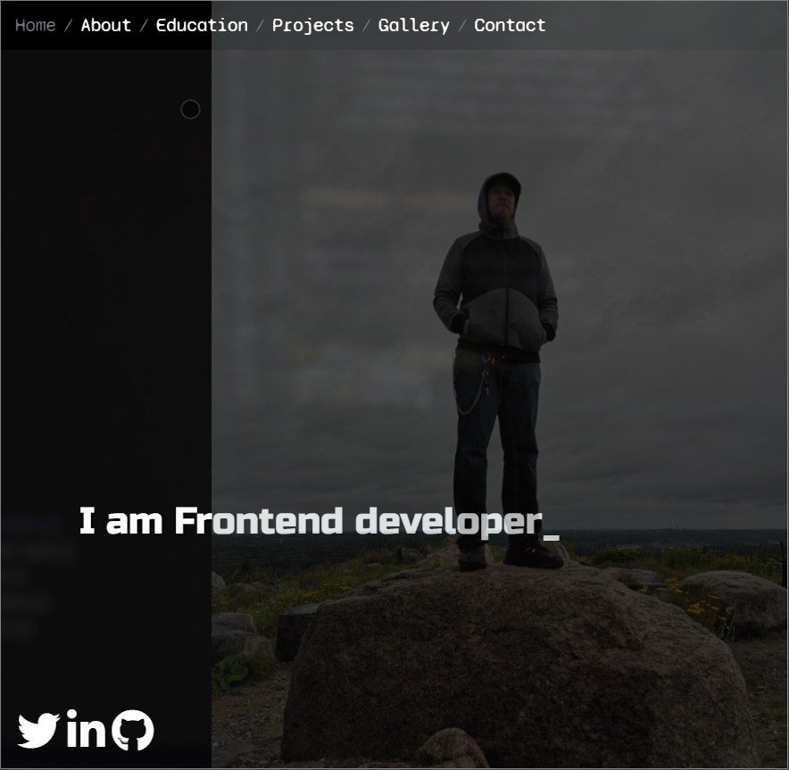

Index page was made with tiny brief and includes personal photograph with videobackground with opacity. Breadcrumb-navigation menu on the top and social media links in the bottom of the page.

About Page

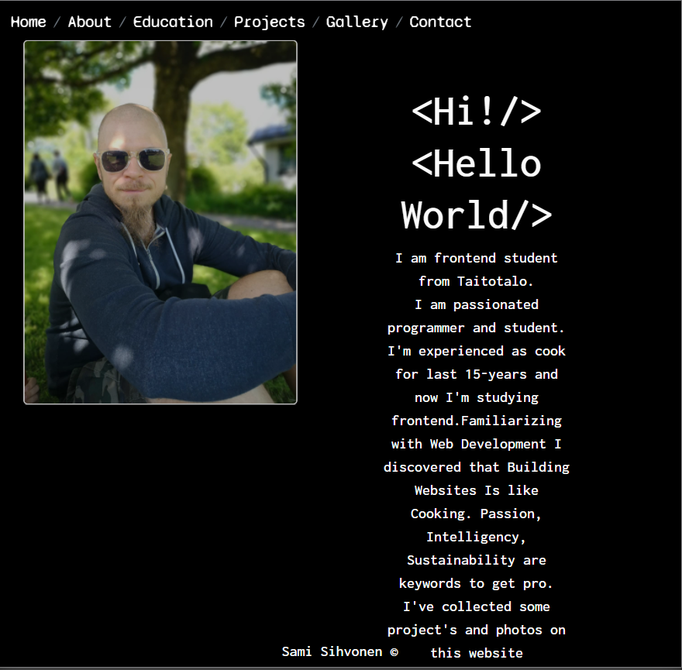 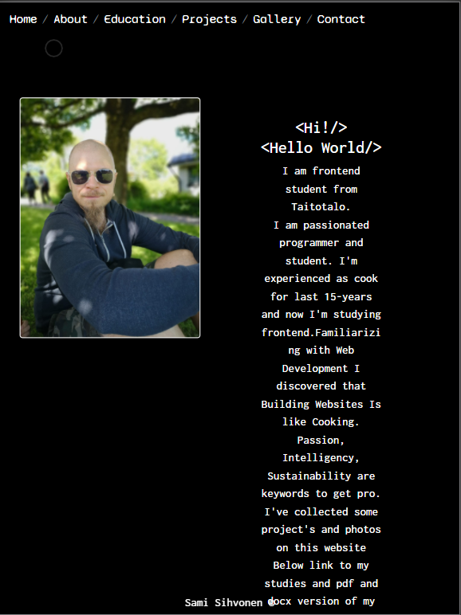 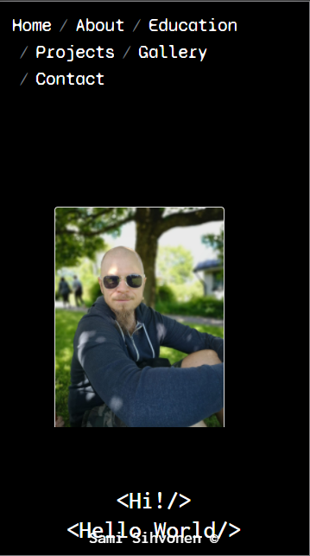 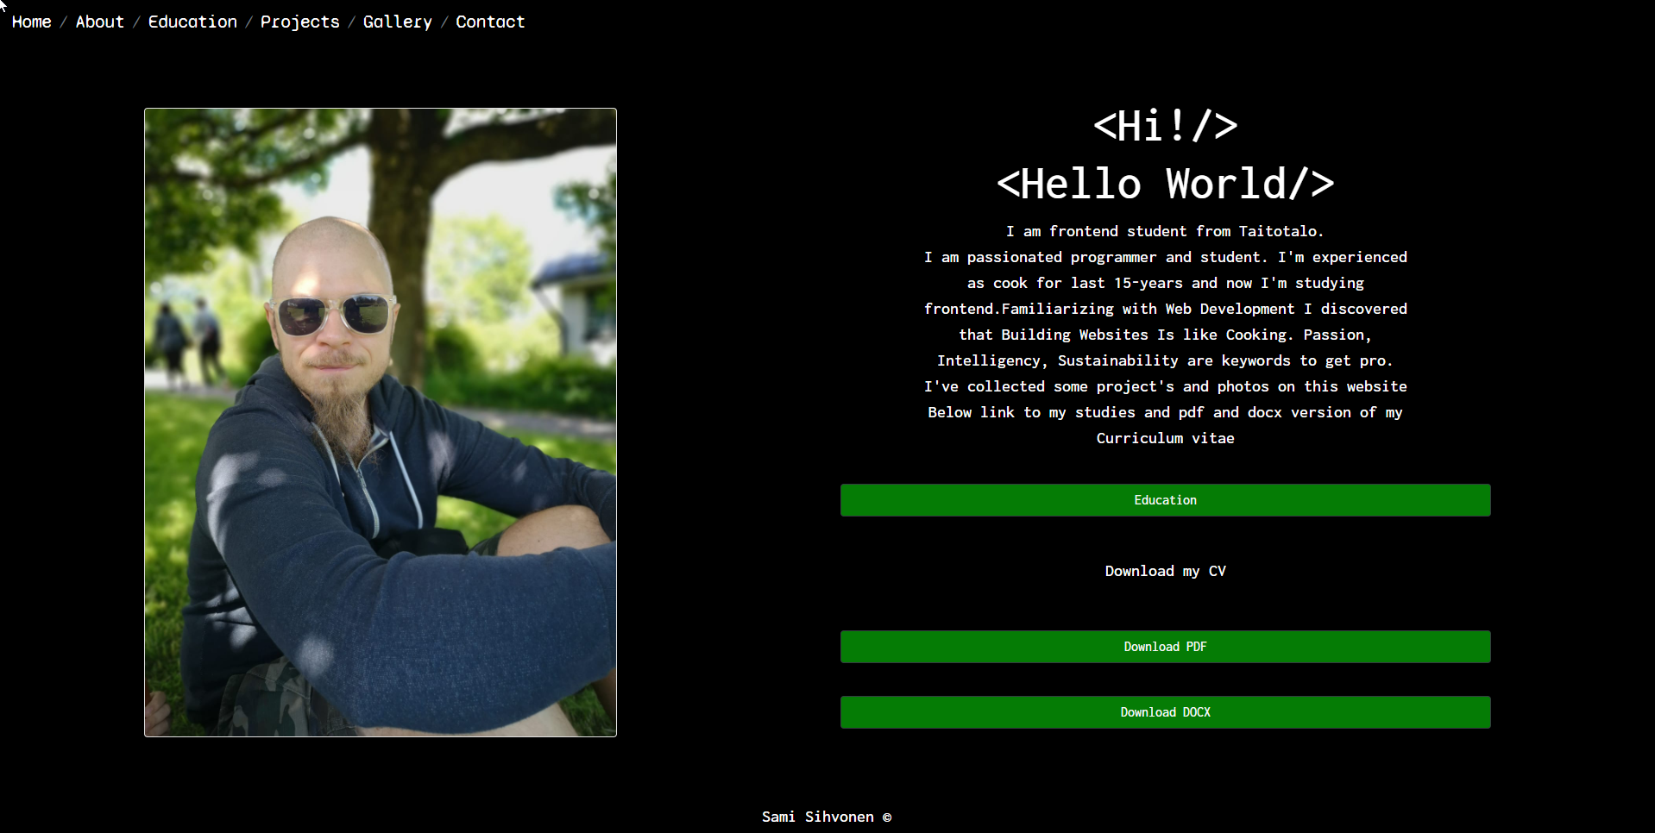

About page with profile-picture, little brief of me, link button to studies and buttons to download my cv. Also with breadcrumb-menu.

Education Page

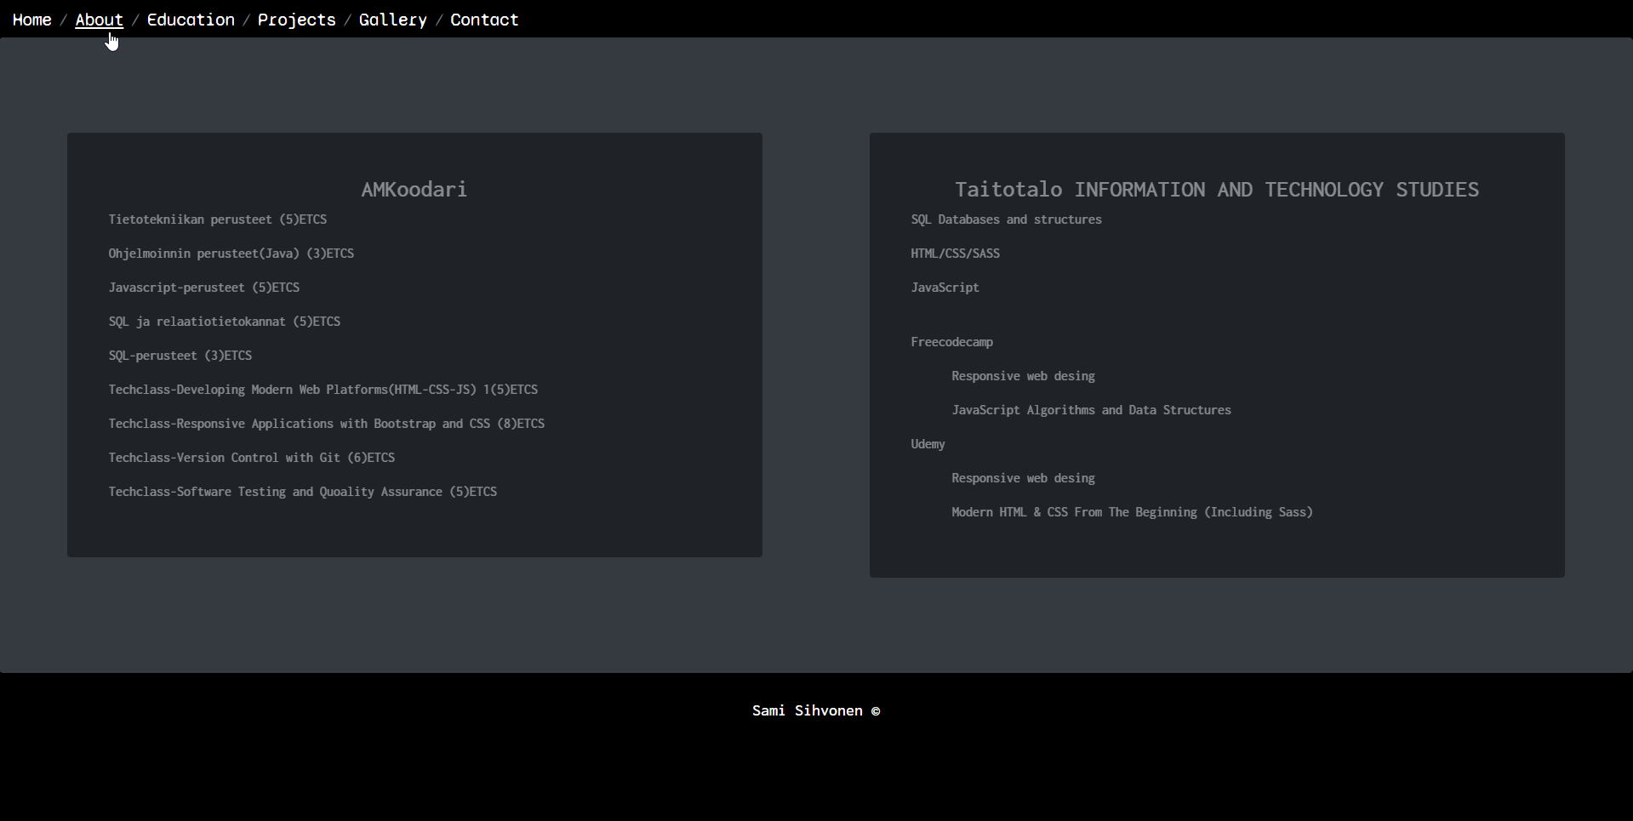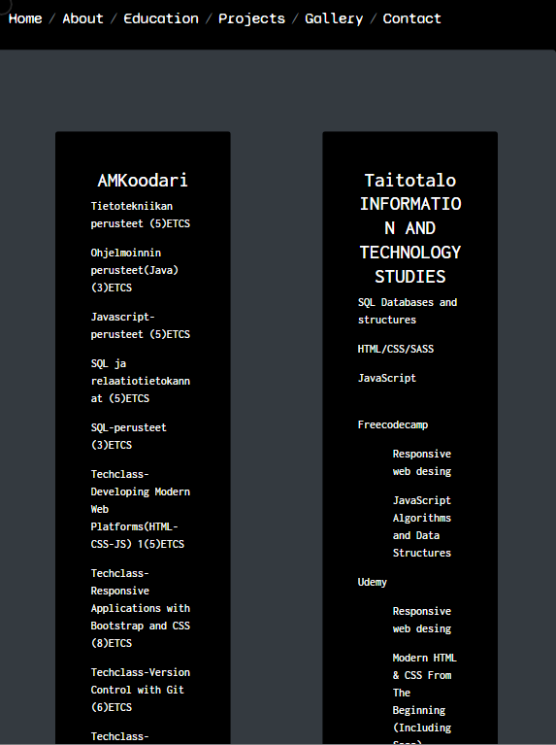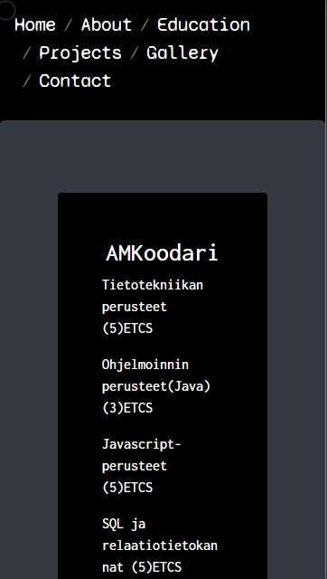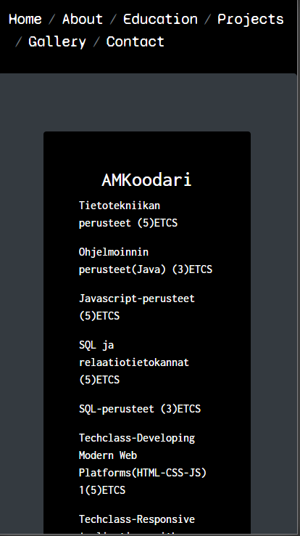

Education page contains some course detail and those are inside bootstrap cards in one row and two columns.

Projects Page

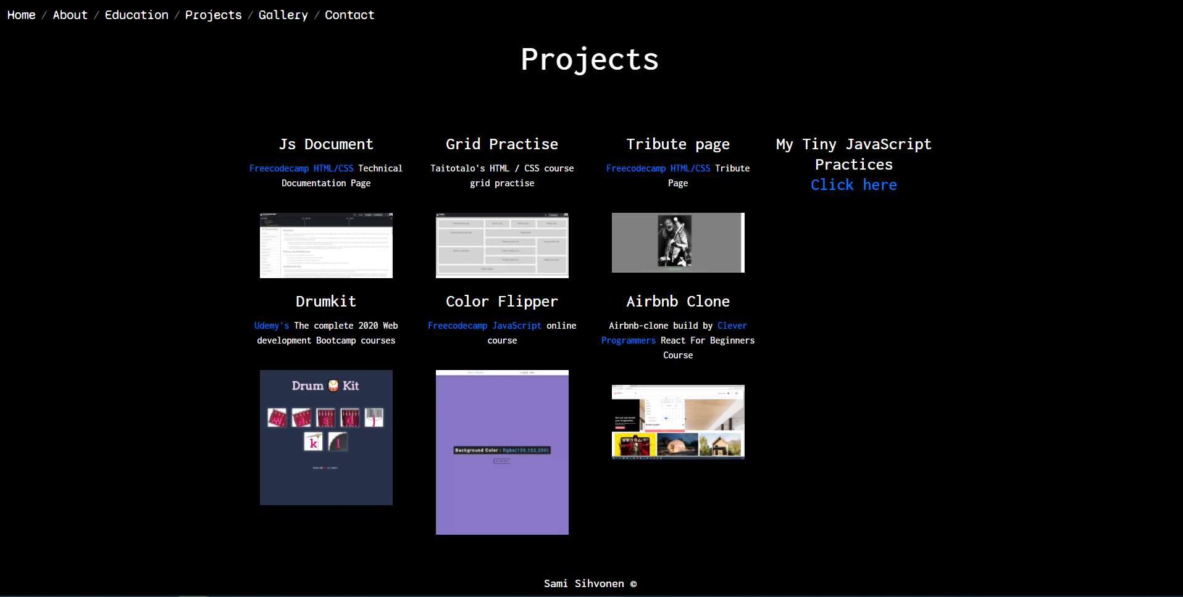 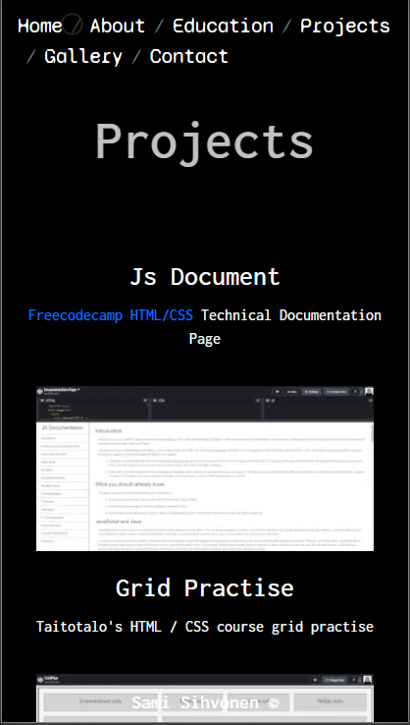 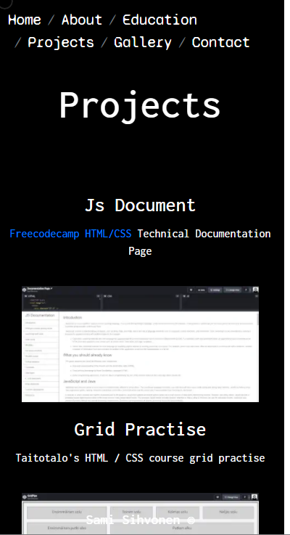 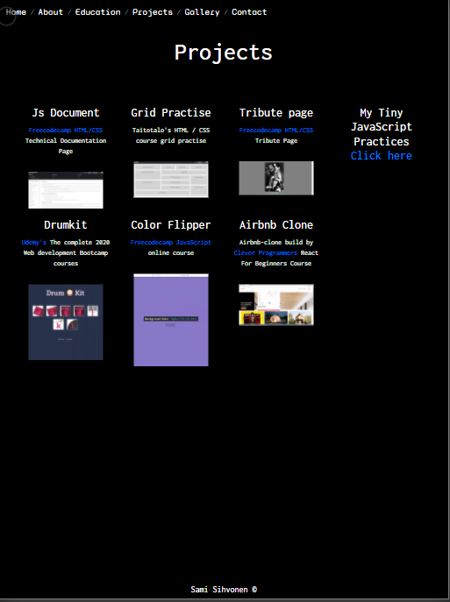

Projects page contains some earlier projects I’ve made and link to JavaScript-tiny projects-files.

Gallery(carousel)

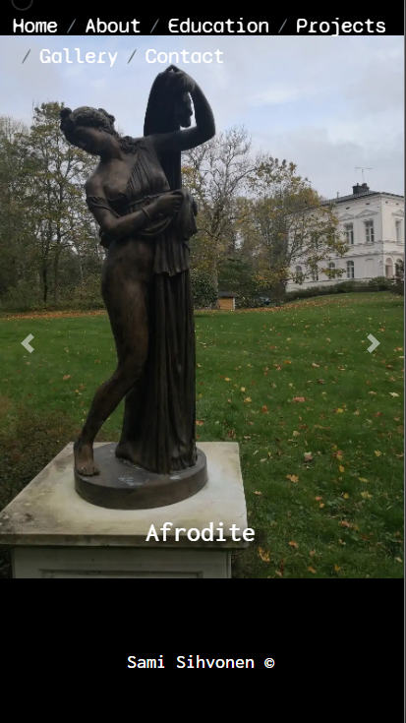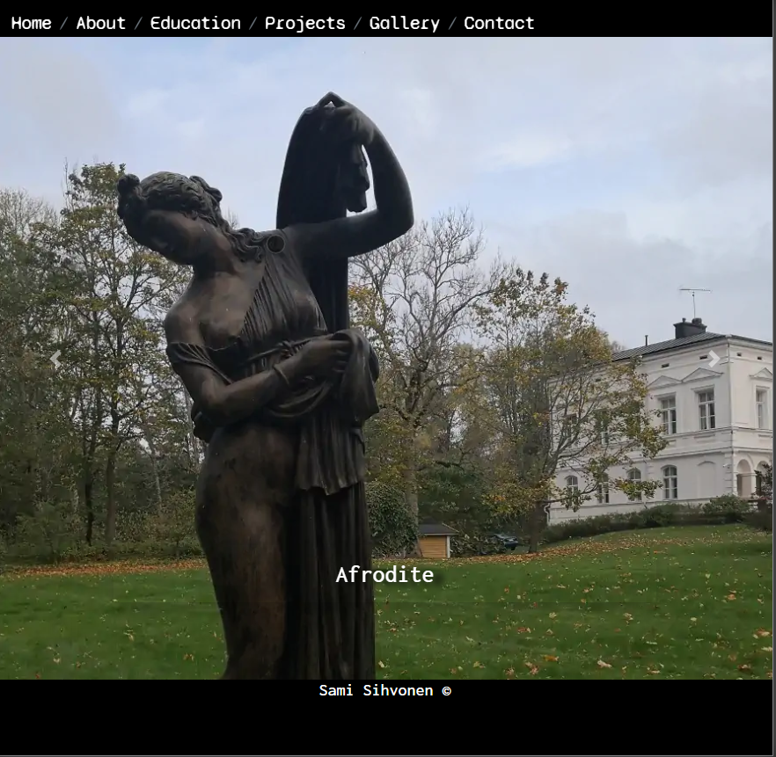 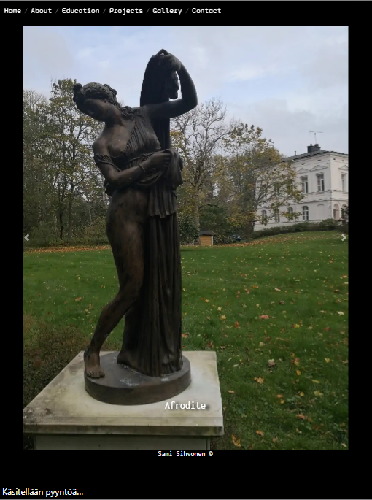 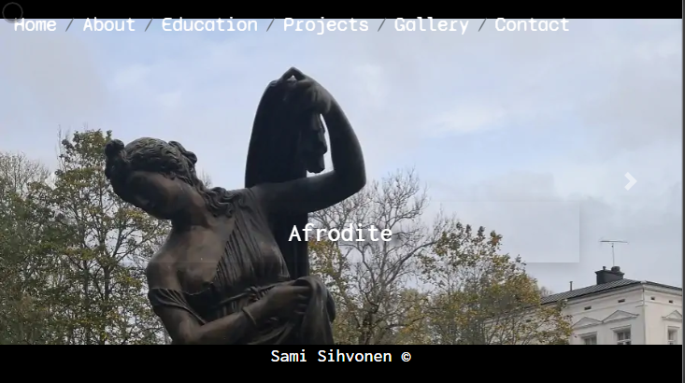

Gallery-section(carousel) was bit a difficult to add breadcrumb on top of it and add youtube-videos also inside carousel.

Contact-section

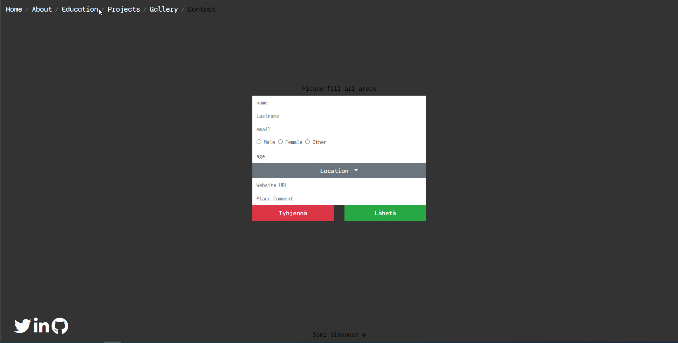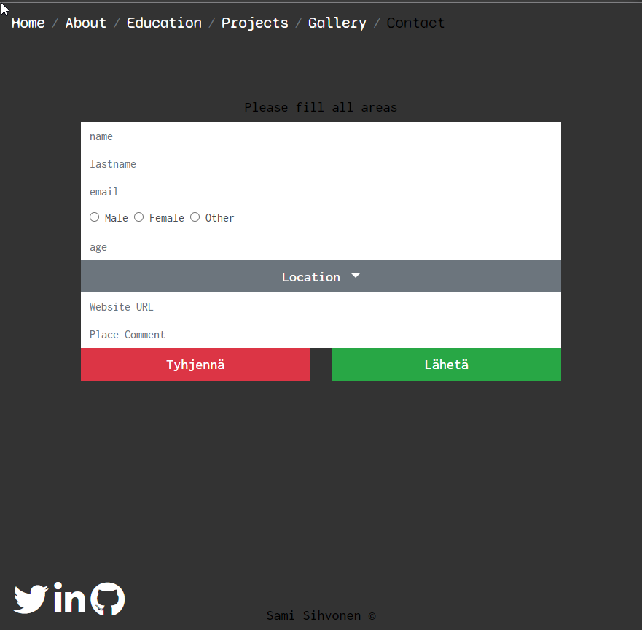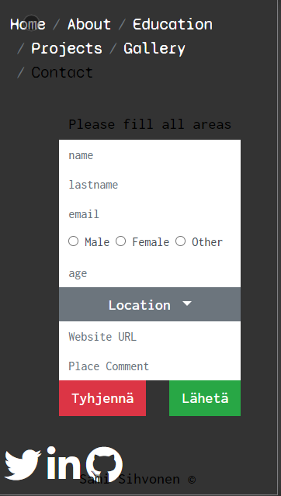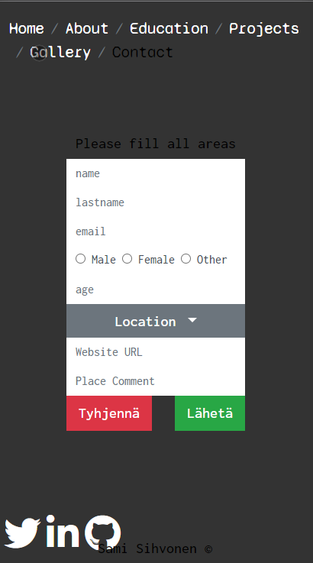

Contact-section is made with breadcrumb, socialmedia buttons, and fullworking form. It’s alson responsive as all pages also.